MATHEMATICS METHODS

MAWA Semester 2 (Unit 3&4) Examination 2018
Calculator-assumed

Marking Key

© MAWA, 2018
Licence Agreement
This examination is Copyright but may be freely used within the school that purchases this licence.
- The items that are contained in this examination are to be used solely in the school for which they are purchased.
- They are not to be shared in any manner with a school which has not purchased their own licence.
- The items and the solutions/marking keys are to be kept confidentially and not copied or made available to anyone who is not a teacher at the school. Teachers may give feedback to students in the form of showing them how the work is marked but students are not to retain a copy of the paper or marking guide until the agreed release date stipulated in the purchasing agreement/licence.

The release date for this exam and marking scheme is
- the end of week 1 of term 4, Fri October 12th 2018

Section Two: Calculator-assumed (100 Marks)

Question 8 (a) (2 marks)
Solution
Bernoulli distribution with parameter
Mathematical behaviours | Marks
- states Bernoulli distribution  - states parameter of | 1  1

Question 8 (b) (2 marks)
Solution
Variance(X)

Mathematical behaviours | Marks
- states correct mean  - states variance | 1  1

Question 9 (a) (2 marks)
Solution
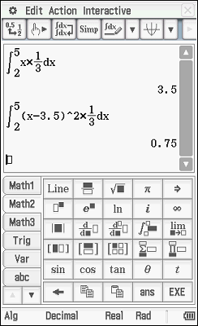

Mathematical behaviours | Marks
- determines the expected value  - determines the variance | 1  1

Question 9 (b) (2 marks)
Solution
Mathematical behaviours | Marks
- determines numerator  - determines denominator | 1  1

Question 9 (c) (3 marks)
Solution
F(x) =
Mathematical behaviours | Marks
- identifies need to integrate f(x)  - determines definite integral using correct limits of integration (2,x)  - determines F(x) and states it as a piecewise function | 1  1  1

Question 9 (d) (2 marks)
Solution
Mathematical behaviours | Marks
- states  - solves for x | 1  1

Question 10 (a) (2 marks)
Solution
Mathematical behaviours | Marks
- substitutes and to obtain required equation  - solves equation to obtain | 1  1
Question 10 (b) (2 marks)
Solution
In 15 years the country’s population =
In 15 years the city’s population = where represents its growth rate
Hence =
Solving gives
Hence the continuous growth rate is approximately 7%.
Mathematical behaviours | Marks
- equates city’s population to 40% of country’s population in 15 years  - solves equation and states percentage growth rate | 1  1

Question 11 (6 marks)
Solution
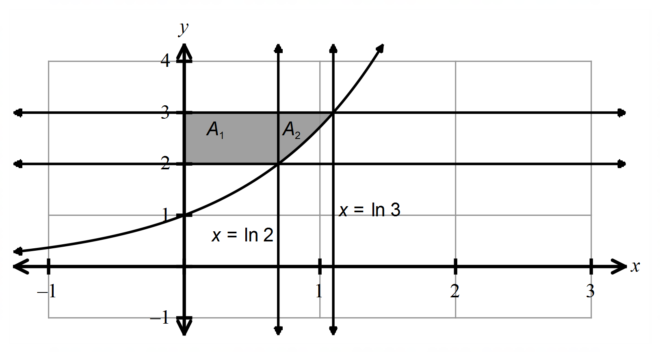

Mathematical behaviours | Marks
- indicates an appropriate expression involving an integral to determine  required area  - indicates x axis values, ln 2 and ln 3  - determines A₁  - substitutes correct bounds to determine A₂  - evaluates integral and A₂  - rearranges expression using log laws and simplifies | 1  1  1  1  1  1

Question 12 (a) (1 mark)
Solution
Confidence interval is $\left(\hat{p}-E,\hat{p}+E\right)=\left(0.53,0.61\right)$
So $\hat{p}=\frac{0.53+0.61}{2}=0.57$
Mathematical behaviours | Marks
- Obtains correct answer | 1

Question 12 (b) (2 marks)
Solution
$E=z_{α}\sqrt{\frac{\hat{p}(1-\hat{p})}{n}}$
ie $0.04=1.96\sqrt{\frac{0.57×0.43}{n}}$
Solving for $n$ gives $n≅588.5$
So the sample size was 589 (approximately)
Mathematical behaviours | Marks
- Uses  - Solves for $n$ and rounds | 1  1

Question 12 (c) (3 marks)
Solution
Mathematical behaviours | Marks
- Substitutesvalues into error equation  - Solves for $z_{α}$  - States level of confidence to at least 1 decimal place | 1  1  1

Question 12 (d) (2 marks)
Solution
From the confidence interval in 10(c), there is a 99.94% probability that $p$ lies between 0.5 and 0.64, and in particular $p>0.5.$ So the claim is justified.
Mathematical behaviours | Marks
- States the claim is justified  - Gives a valid reason | 1  1

Question 13 (a) (3 marks)
Solution
Since velocity and acceleration are opposing one another, the particle is slowing down
Mathematical behaviours | Marks
- calculates  - differentiates to obtain and  - states particle is slowing down | 1  1  1

Question 13 (b) (2 marks)
Solution
Hence its final position is 144m from the origin.
Mathematical behaviours | Marks
- integrates velocity equation to determine displacement equation including  - substitutes , calculates and states final position, with unit | 1  1

Question 14 (4 marks)
Solution
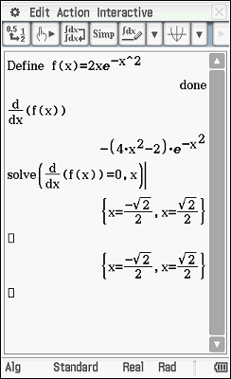
Mathematical behaviours | Marks
- states  - differentiates  - solves  - states co-ordinates of | 1  1  1  1

Question 15 (a) (1 mark)
Solution
Probability of winning a prize = 0.1 + 0.001
= 0.101
Mathematical behaviours | Marks
- uses Addition Principle to calculate the correct probability | 1

Question 15 (b) (2 marks)
Solution
X$\sim Bin(20,0.101)$
Mathematical behaviours | Marks
- states Binomial distribution  - states correct parameters | 1  1

Question 15 (c) (2 marks)
Solution
= $\left(\begin{matrix}20 \\ 0\end{matrix}\right){\left(0.101\right)}^{0}{\left(0.899\right)}^{20}+\left(\begin{matrix}20 \\ 1\end{matrix}\right){\left(0.101\right)}^{1}{\left(0.899\right)}^{19}+\left(\begin{matrix}20 \\ 2\end{matrix}\right){\left(0.101\right)}^{2}{\left(0.899\right)}^{18}+\left(\begin{matrix}20 \\ 3\end{matrix}\right){\left(0.101\right)}^{3}{\left(0.899\right)}^{17}$
Mathematical behaviours | Marks
- identifies that “no more than 3 prizes” means “can win 0,1,2, or 3 prizes”  - states correct expression for the probability | 1  1

Question 15 (d) (1 mark)
Solution
Bincdf(0,3,20,0.101)=0.8634
Mathematical behaviours | Marks
- states probability | 1

Question 15 (e) (1 mark)
Solution
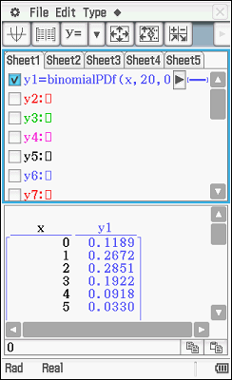
Using CAS,
k=3



Mathematical behaviours | Marks
- states k=3 | 1

Question 16 (a) (i) (2 marks)
Solution
= -3 + 4 – 4 = -3
Mathematical behaviours | Marks
- indicates addition of signed areas  - determines result | 1  1

Question 16 (a) (ii) (2 marks)
Solution
Area = 3+4+4=11
Mathematical behaviours | Marks
- expresses the area as a sum of areas  - determines result | 1  1

Question 16 (b) (3 marks)
Solution
Mathematical behaviours | Marks
- applies the additivity of integrals to split the integral  - applies the linearity of integrals to deduce  - determines result | 1  1  1

Question 16 (c) (3 marks)
Solution
Maximum value of occurs where
Hence, max is 1.
Mathematical behaviours | Marks
- applies the Fundamental Theorem  - determines maximum value | 1  1  1

Question 17 (a) (1 mark)
Solution
 | small | medium | large
Proportion of peaches |  |  | 0.1538

Mathematical behaviours | Marks
- determines both probabilities | 1

Question 17 (b) (3 marks)
Solution

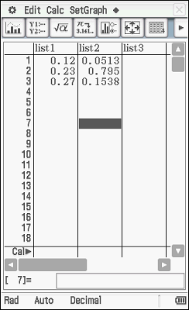
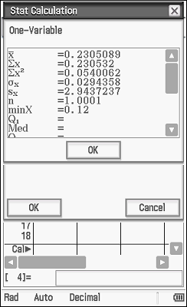

Mathematical behaviours | Marks
- states a calculation to determine the mean or variance  - determines mean  - determines standard deviation | 1  1  1

Question 17 (c) (3 marks)
Solution
Mathematical behaviours | Marks
- states linear transformation required  - determines mean  - determines standard deviation | 1  1  1

Question 18 (a) (4 marks)
Solution
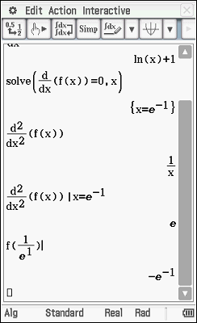
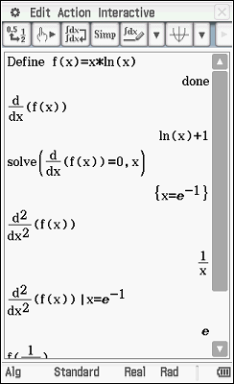
For stationary points,
Thus exact coordinates of minimum turning point =
Mathematical behaviours | Marks
- differentiates correctly using the product rule  - equates first derivative to zero to determine x co-ordinate of stationary  points  - uses second derivative test to determine nature of turning point  - determines correct coordinates of turning point | 1  1  1  1

Question 18 (b) (1 mark)
Solution
Since
Mathematical behaviours | Marks
- states second derivative is never zero hence no P.O.I. | 1

Question 19 (a) (2 marks)
Solution
Mathematical behaviours | Marks
- substitutes  - solves the equation | 1  1

Question 19 (b) (2 marks)
Solution
Mathematical behaviours | Marks
- rearranges log expression correctly  - substitutes and states in terms of | 1  1

Question 19 (c) (1 mark)
Solution
Mathematical behaviours | Marks
- evaluates the ratio correctly | 1

Question 20 (a) (6 marks)
Solution
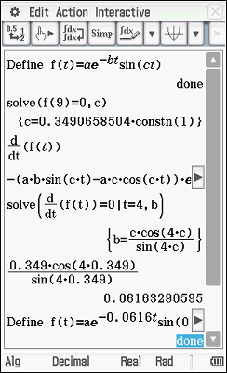

$\frac{dy}{dt}=-abe^{-bt}\sin{ct}+ace^{-bt}\cos{ct}=ae^{-bt}\left(c\cos{ct-b\sin{ct}}\right)$
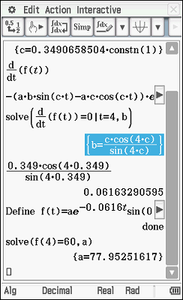

Mathematical behaviours | Marks
- uses (9,0) to conclude  - solves for $c$  - determines derivative function  - equates derivative function to 0 at and solves for $b$  - uses (4,60) to solve for $a$  - gives all answers correct to 3 significant figures | 1  1  1  1  1  1

Question 20 (b) (3 marks)
Solution
$y\left(t+\frac{π}{c}\right)=ae^{-b\left(t+\frac{π}{c}\right)}\sin\left(c\left(t+\frac{π}{c}\right)\right)$
$={ae^{-bt}e}^{-\frac{bπ}{c}}\sin\left(ct+π\right)$
$=-{ae^{-bt}e}^{-\frac{bπ}{c}}\sin{ct}=-ry\left(t\right)$
Mathematical behaviours | Marks
- replaces with to obtain required function  - uses indices laws to factor out  - uses to complete argument | 1  1  1

Question 20 (c) (3 marks)
Solution
The mass travels 120 cm in the first 9 seconds.
In the next 9-second period the mass travels $120r$ cm,
where from part (b) $r=e^{-πb/c}≅e^{-π×\frac{0.0616}{0.349}}≅0.574$
Hence distance travelled between its first and second return to the origin is
Mathematical behaviours | Marks
- deduces that the mass travels 120 m in the first 9 seconds  - evaluates r  - obtains correct answer to the nearest centimetre | 1  1  1

Question 21 (a) (3 marks)
Solution
So the 95% confidence interval is $0.629<p<0.699$
Mathematical behaviours | Marks
- calculates sample proportion correctly  - calculate standard error correctly  - calculates interval correctly | 1  1  1

Question 21 (b) (2 marks)
Solution
Because the old satisfaction rate (65%) lies within the new confidence interval, the recent survey does not provide conclusive evidence that the satisfaction rate has improved.
Mathematical behaviours | Marks
- states that survey is not conclusive  - states a valid reason | 1  1

Question 21 (c) (i) (3 marks)
Solution
Mathematical behaviours | Marks
- substitutes  - expresses error as a constant  - deduces error | 1  1  1

Question 21 (c) (ii) (1 mark)
Solution
Mathematical behaviours | Marks
- states Margin of error | 1

Question 21 (c) (iii) (1 mark)
Solution
Mathematical behaviours | Marks
- uses the relationship between the errors to draw valid conclusion | 1

Question 21 (d) (3 marks)
Solution
True margin of error
Mathematical behaviours | Marks
- substitute and equates true to for simple interval  - solves inequality to determine  - states 97% level of confidence | 1  1  1

Question 21 (e) (1 mark)
Solution
Mathematical behaviours | Marks
- calculates and deduces that sample size is appropriate | 1

